Seminar Report on

Performance Analysis of Binary Neural Networks on ARM-based CPU Core on PYNQ-Z1 Board


Under the guidance of Dr. Sumitra Kisan Assistant Professor

Submitted by
Jibesh Kumar Panda
7th Semester, Bachelor of Technology
Department of Computer Science and Engineering Veer Surendra Sai University of Technology
Burla, Odisha - 768018

Department of Computer Science and Engineering Veer Surendra Sai University of Technology
Burla, Odisha - 768018


DECLARATION

I declare that this written submission represents the ideas in my own words, and where others’ ideas or words have been included, I have adequately cited and referenced the original sources. I also declare that I have adhered to the principles of honesty and integrity and have not misrepresented, fabricated, or falsified any idea, data, fact, or source in my submission.

Jibesh Kumar Panda
Regd No.: 2102040024
7th Semester, Bachelor of Technology Dept. of Computer Science and Engineering Veer Surendra Sai University of Technology

Contents
- Introduction 1
  - Motivation . . . . . . . . . . . . . . . . . . . . . . . . . . . . . . . . . . . . . . 1
  - Problem Statement . . . . . . . . . . . . . . . . . . . . . . . . . . . . . . . . . 2
- Literature Review 2
- Binary Neural Networks 2
  - Weight Binarization . . . . . . . . . . . . . . . . . . . . . . . . . . . . . . . . . 2
  - Straight Through Estimator . . . . . . . . . . . . . . . . . . . . . . . . . . . . 3
  - Activation Binarization . . . . . . . . . . . . . . . . . . . . . . . . . . . . . . . 3
- The PYNQ-Z1 Board 4
- Experimental Setup 4
  - Loading the Boot Image to microSD Card . . . . . . . . . . . . . . . . . . . . 5
  - Booting the PYNQ-Z1 Board . . . . . . . . . . . . . . . . . . . . . . . . . . . . 5
  - Serial Access to the Terminal . . . . . . . . . . . . . . . . . . . . . . . . . . . . 5
  - Access via Secure Shell (SSH) . . . . . . . . . . . . . . . . . . . . . . . . . . . 6
  - Jupyter Notebook on the PYNQ-Z1 Platform . . . . . . . . . . . . . . . . . . 6
  - Installation of BNN-PYNQ . . . . . . . . . . . . . . . . . . . . . . . . . . . . . 6
  - Installation of perf: The Performance Measurement Tool . . . . . . . . . . . 7
- Experimentation 7
  - Specification of Experiment Environment . . . . . . . . . . . . . . . . . . . . 7
  - Components of the Experimentation . . . . . . . . . . . . . . . . . . . . . . . 7
    - Preparation of Inference Scripts . . . . . . . . . . . . . . . . . . . . . . 9
  - The Process of Performance Measurement 10
    - Context Switches 11
    - CPU Clock 11
    - Task Clock 11
    - CPU Migrations 11
    - Emulation Faults 11
    - Major Faults 11
    - Minor Faults 11
    - Duration Time 11
    - Processor Specific Metrics 12
  - Results: Performance Metrics and Values 12
- Analysis of Performance Metrics 12
  - Comparison between Models initialized with Hardware (HW) Runtime 12
  - Comparison between Models initialized with Software (SW) Runtime 14
  - Comparison between Models trained on different Datasets 15
  - Role of number of bits 15
  - Comparison between hardware and software runtime. 16
- Observations 17
  - Limitations of the Device for the Experimentation 17
  - An overview of the Network Architecture 17
  - Potential Bottlenecks 18

 | 8.3.1 | Convolutional Models . . . . . . . . . . . . . . . . . . . . . . . . . . . | 18
 | 8.3.2 | General Performance Issues . . . . . . . . . . . . . . . . . . . . . . . . | 18
8.4 | Areas | of Improvement . . . . . . . . . . . . . . . . . . . . . . . . . . . . . . . | 19
 | 8.4.1 | Optimization of Convolutional Operations . . . . . . . . . . . . . . . | 19
 | 8.4.2 | Memory Management . . . . . . . . . . . . . . . . . . . . . . . . . . . | 19
 | 8.4.3 | Improvement in Thread Synchronization . . . . . . . . . . . . . . . . | 19
 | 8.4.4 | Reduction of Pipeline Flushes . . . . . . . . . . . . . . . . . . . . . . . | 19
 | 8.4.5 | Bitstreams for other TinyML models . . . . . . . . . . . . . . . . . . . | 19
9 Conclusion 20

List of Figures
- Weight Binarization in Forward Pass . . . . . . . . . . . . . . . . . . . . . . . 3
- Activation Binarization in Forward Pass with STE in Backward Pass . . . . . 3
- The PYNQ-Z1 Hardware Platform . . . . . . . . . . . . . . . . . . . . . . . . 4
- Serial Access using PuTTY . . . . . . . . . . . . . . . . . . . . . . . . . . . . . 6
- Task Clock (msec) for HW Runtimes of the Models 12
- L1 Data Cache References for HW Runtimes of the Models 13
- L1 Data Cache Refills for HW Runtimes of the Models 13
- Context Switches for HW Runtimes of the Models 13
- PC Writes for HW Runtimes of the Models 14
- CPU Cycles for SW Runtimes of the Models 14
- CPU Migrations for SW Runtimes of the Models 15
- Rate of store instructions retired 15
- Context Switch Time in seconds 16
- Relative minor faults in hardware and software runtime 16
- Relative major faults in hardware and software runtime 17

List of Tables
- Specifications of CPU . . . . . . . . . . . . . . . . . . . . . . . . . . . . . . . . 8
- Specifications of Processors . . . . . . . . . . . . . . . . . . . . . . . . . . . . 8
- Specifications of Memory . . . . . . . . . . . . . . . . . . . . . . . . . . . . . 9
- Specifications of Disk (microSD Card) . . . . . . . . . . . . . . . . . . . . . . 9
- Summary of classifier models, weight bit(s), activation bit(s), and datasets. 9
- ARMv7 Cortex-A9 Performance Metrics and Their Significance 10
- CNV W1A1 HW Architecture Description 18

Performance Analysis of Binary Neural Networks on ARM-based CPU Core on PYNQ-Z1 Board
Abstract
Neural networks introduce substantial computational requirements. Inherently, high performance computing units are necessary for training and performing inference on large-scale neural networks. To leverage edge computing on sensors and mobile de- vices, the TinyML paradigm has emerged. As an instance, with weights and activations binarized, binarized neural networks (BNN) significantly save storage and computa- tion. The hardware platform PYNQ-Z1 uses the PYNQ framework for efficient imple- mentation of BNNs. This study aims at evaluating the performance of such models. The critical bottlenecks and potential areas of optimisation were identified through detailed analysis. The architectural and algorithmic improvements are further investigated with a motive towards the utilisation of unique features of the device for greater performance in edge AI applications.
Index Terms: BNN, PYNQ-Z1, perf

Introduction
Deep Learning has undergone significant growth fueled by enhanced neural network archi- tectures, availability of large-scale datasets, and use of resources with high computational power in training and inferences. However, the use of such computationally expensive mod- els in real world resource-limited devices induces a challenge of reducing the resource re- quirements without affecting the accuracy. To overcome the limitations of computational power in edge devices, the paradigm has shifted towards TinyML [1]. With an aspect of developing embedded ML technique [2], it also encourages to make changes in the network topology structure, weights, activation, loss functions and many more. As one of the early solutions to the network compression problem, low precision representation of network weights made an appearance in [3].
In quantization, the weights are of less bits as compared to their floating point counter- parts. Binarization is a 1-bit quantization i.e., the weight carries either of the two values, namely -1(0) and +1(1). Binary Neural Networks (BNN) are based on the basic principle of binarization of weights and activation. They are proven to reduce memory storage re- quirements and power consumption. In real-world scenario, BNN has gained prominence because of its ability to be implemented on Field Programmable Gate Arrays (FPGA) and other hardware accelerators.
The PYNQ-Z1 board [4] is the hardware platform of open-source framework PYNQ that enables exploitation of the capabilities of Xilinx Zynq All Programmable SoCs (APSoCs) [5]. FPGA implementations of BNN are contained in PYNQ framework. Inherently, the PYNQ-Z1 hardware platform serves as an ideal candidate for experimentation on BNN, performance measurement being the prime objective.

Motivation
Although the implementations of BNN in PYNQ framework are in correspondence with the accelerator capabilities of the PYNQ-Z1 hardware platform, there could be inefficient meth- ods for certain computations that would result a performance degradation. Identification of such bottlenecks will set the platform for architectural and algorithmic improvements.

Problem Statement
To detect potential bottlenecks causing performance degradation of BNN inferences con- ducted on the PYNQ-Z1 hardware platform, and to carry out further improvements by analysing the architectural root of the bottlenecks.

Literature Review
Tiny Machine Learning (TinyML) can be defined as the deployment of machine learning (ML) models on resource-constrained devices. With a broad range of applications in Inter- net of Things (IoT) and embedded systems, it enables utilization of unique features of the device in making an inference with low computational complexity and power consump- tion. Evaluation of such models have been carried out through assessment of inference speed, model accuracy and energy efficiency [6].
Binary Neural Networks are suitable for deployment on edge devices being beneficial in terms of both perfomrance and energy efficiency [7]. Zhang et al.’s study from 2021 exam- ined TinyML models’ performance on several ARM Cortex-A cores. They discovered that more recent Cortex-A core generations provide better energy economy and performance, which is essential for implementing sophisticated machine learning algorithms on devices like the PYNQ-Z1 [8].
In a case study, Li and Wang (2022) assessed the performance of a CNN-based TinyML model for image classification on the PYNQ-Z1 board. They reported fast inference times and emphasised the importance of FPGA acceleration in optimising computational activi- ties that complement ARM Cortex-A9 CPUs [9]. Chen et al. (2023) studied the energy effi- ciency of TinyML models running on ARM-based devices. They concluded that optimising model architecture and exploiting hardware accelerators like the FPGA on the PYNQ-Z1 can drastically reduce power consumption while maintaining inference accuracy [10].

Binary Neural Networks
Binary Neural Networks are an extreme case of quantization where precision, being one of the dimensions possessing redundancy in traditional neural networks [11], is limited to 1- bit. With binarization of weights, input and output activations, full binarization is achieved. Resource finity of mobile devices denotes the notability of such a technique. To justify the usefulness of BNN, its basic components are explicated in the following subsections.

Weight Binarization
In a neural network, weights characterize the influence of elements of input on the output that a layer produces. In BNN, the weights carry either of the two possible values, namely
-1 and +1. Bit 0 and 1 are used to resemble -1 and +1 respectively. In each forward pass, weights undergo binarization, yet the actual completion of weight binarization is acquired after training. In order to minimize loss, the real-valued weights are kept and updated dur- ing training, and are discarded after complete weight binarization.
Let w_{R} be the real-valued weight. Two functions are applied to it in the forward pass, in order to obtain the binarized weight value w_{B}.
clip(w_{R}) = max(−1, min(1, x_{R})) (1)

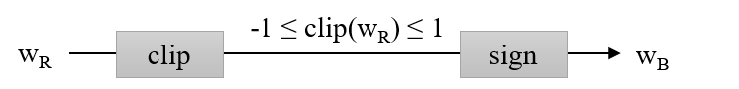
Figure 1: Weight Binarization in Forward Pass

w_{B} = sign(w_{R}
) = +1 if w_{R} ≥ 0,
−1 otherwise.
(
(2)

Straight Through Estimator
A gradient denotes the change in weights with respect to the change in error of model inference. To overcome the issue of zero-valued threshold functions, where derivative (if gradient descent were used) would result all zeros, Straight Through Estimator (STE) was considered. It simply back propagates the hard threshold function resembling an identity function [12]. For backward pass of gradients in a BNN, STE is used.

dw_{B} dw_{R}
= STE(w_{R}
) = 1 if |w_{R}| ≤ 1,
0 otherwise.
(
(3)

Activation Binarization
With a goal of introducing non-linearity to the output of a neuron, activation functions make the decision regarding the activation of neurons. In BNN, during forward pass, binarization of activations takes place along with weight binarization. However, real-valued activations are maintained during the training phase.
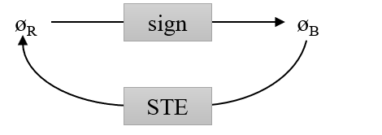
Figure 2: Activation Binarization in Forward Pass with STE in Backward Pass
Let ϕ_{R} be the real-valued activation. The corresponding binarized activation is obtained by performing signum function on ϕ_{R}.

ϕ_{B} = sign(ϕ_{R}
) = +1 if ϕ_{R} ≥ 0,
−1 otherwise.
(
(4)

In the backward pass, clipped STE is applied. It is ample to note that no clipping is per- formed on the activations during forward pass. The clip operation is represented as Approx below.

dϕb = STE(ϕ dϕ_{R}
−1 if ϕ < −1
R
) (5)

Approx(ϕ) =
ϕ if ϕ ≥ −1 & ϕ ≤ 1
1 otherwise.

(6)

Although the binarization of weights and activations provide impressive reduction in power consumption and resource requirements, further improvements are still to be achieved.

The PYNQ-Z1 Board
The PYNQ open-source framework facilitates utilization of the capabilities of Xilinx Zynq APSoCs. The PYNQ-Z1 board is its hardware platform, where the APSoC can be pro- grammed using Python. It has a 650MHz dual-core Cortex-A9 processor. The on-board FPGA is programmable from microSD card as well as Quad Serial Peripheral Interface (QSPI), and Joint Test Action Group (JTAG). Flexible power supply methods are available for the same, namely supply through USB, and through Direct Current (DC) adapter with 7V-15V power out. USB, Ethernet, Audio and Video Ports present on the board account for Serial Access, Internet connectivity, and audio-visual inputs/outputs. The board has one 512MB Double Data Rate 3 (DDR3) Random Access Memory (RAM) and DDR3 memory controller with 8 Direct Memory Access (DMA) channels.
From the architecture of Zynq APSoC of the PYNQ-Z1 board, it is evident that there are two levels of cache implemented. The first level contains two Cortex-A9 MPCore 32/32 KB instruction/data caches and the second level is formed of one 512 Kbyte L2 Cache.
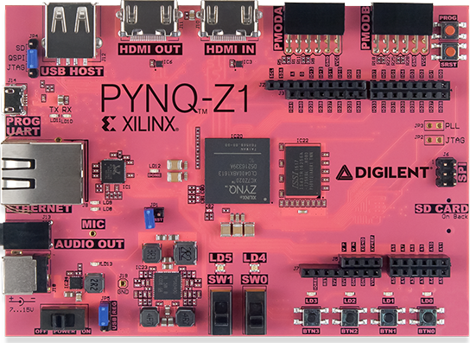
Figure 3: The PYNQ-Z1 Hardware Platform

Experimental Setup
For accurate measurement of system performance metrics for inference using available BNN models, several setup steps are followed. It is first ensured that the PYNQ-Z1 hardware platform is accessible from the host device. Secondly, the availability of active Internet con- nection to the platform is considered for installation of required packages and modules. The BNN-PYNQ module is installed and verified [14]. Further, an appropriate version of perf tool was identified and loaded properly on the platform. As an indication to the com- pletion of basic experimental setup, basic commands of perf were made run and the results were analysed.

Loading the Boot Image to microSD Card
PYNQ microSD card images can be either built from source [15] or be obtained from the re- leases [16]. Using Win32 Disk Imager [17] on the Windows host device, the boot image was written to the 64 GB (minimum required: 8GB) microSD Card. Upon a successful write, the microSD Card would now have its storage space divided into two disk partitions. First one of nearly 100 MB (99.7 MB for pynq z1 v2.1.img) has BOOT.bin, Devicetree.dtb, uEnv.txt, uImage files that initiate booting process. The second partition, with the remaining storage space, serves as the ext4 file system.

Booting the PYNQ-Z1 Board
In order to boot the PYNQ-Z1 hardware platform with microSD card [13], the following set of operations were performed.
- The microSD Card containing the boot image was inserted to the J9 Port (present on the back of the PYNQ-Z1 board).
- Since the power supply is provided from host device, Universal Asynchronous Re- ceiver/Transmitter (UART) cable was connected to the J14 Port.
- The JP5 Jumper was set to Universal Synchronous Bus (USB).
- The JP4 Jumper was set to microSD-Quad Serial Peripheral Interface (QSPI).
- To provide access to the Internet, an Ethernet Cable was connected to the J8 Port (RJ45).
- Power Switch SW-4 was turned ON.
The booting process is initiated by retrieving the image written to the microSD Card. At first, it reads the model and board along with memory and storage details. The I/O com- ponents are then detected. The Linux-4.9.0-xilinx kernel is loaded through the load address and entry point obtained from the image. CPU and Memory initialization (including cache setup) is performed, followed by configuration of file system, drivers and services.
In addition to their programmable functionalities, Light Emitting Diodes (LED) present on the board are also used to indicate success of the booting process. The LD13 (Red) LED turned ON immediately after turning the SW-4 Power Switch ON. Following which, the LD12 (Light Green) LED turned ON. After 45 seconds, the LEDs LD0-LD3 (Light Green) along with LD4 and LD5 (Blue) kept blinking simultaneously and after eight blinks, LD4 and LD5 turned OFF leaving LD0-LD3 remain ON.

Serial Access to the Terminal
From the Device Manager interface of Windows, Port number is noted (e.g.: COM11). Us- ing PuTTY [18] the Terminal of the PYNQ-Z1 board is accessed with a baud rate 115200 at the noted Port number. The Internet Protocol (IP) Address of a device connected to the Internet is essential in order to establish a Secure Shell (SSH) connection. Execution of ifcon- fig command on the terminal accessed provides information about the network interfaces, which includes the required IP address.

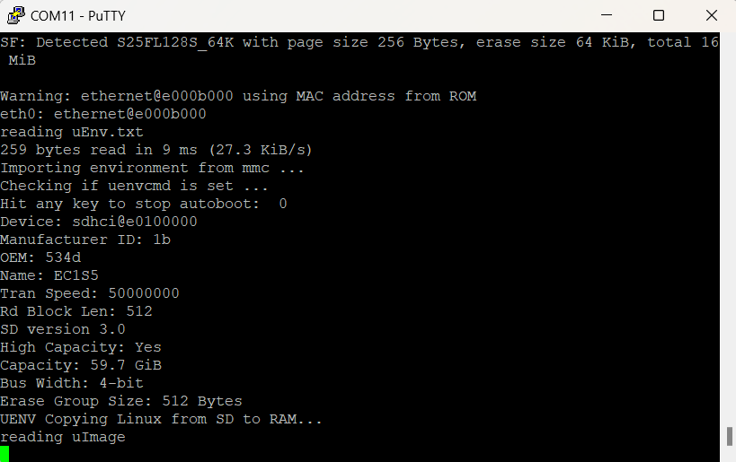
Figure 4: Serial Access using PuTTY

Access via Secure Shell (SSH)
After obtaining the IP Address of the PYNQ-Z1 hardware platform, an SSH connection can be established from any terminal of a host device in the same subnet as that of the PYNQ-Z1 board. For the same, xilinx should be used as the username and password (which can be configured later).

Jupyter Notebook on the PYNQ-Z1 Platform
The IP Address of the PYNQ-Z1 board, followed by Port number 9090 separated with a colon represents the socket address of the Jupyter Notebook process running on the PYNQ- Z1 board. To enable access to the folders and files contained in the path /home/xilinx/ jupyter notebooks of the PYNQ-Z1 board in Jupyter Notebook, the above socket address is browsed over HyperText Transfer Protocol (HTTP).

Installation of BNN-PYNQ
Python installer pip was installed using sudo apt-get install python3-pip. It helps in installing BNN-PYNQ directly from GitHub source [14]. The installed module BNN-PYNQ can be imported as bnn. However, during initialization of CnvClassifier model of bnn module, an OSError: cannot load library was encountered. The command !sudo ln -s /usr/lib/libmicroSDs lib.so /usr/lib/libcma.so resolves the encountered error and installation was verified by exe- cuting one of the example notebooks provided in BNN-PYNQ.

Installation of perf: The Performance Measurement Tool
After failed attempts of installing perf through recommended commands, manual instal- lation was carried out. The package file in Tape Archive (TAR) GNU ZIP (GZ) format (.tar.gz) was downloaded from ubuntu archive. It was then unzipped using tar command and library was built using sudo make command inside the perf sub-folder and copied to the bin. The installation was verified with execution of simple perf commands.

Experimentation
After setting up the required environment, the TinyML models are used to prepare infer- ence scripts in Python. After thorough testing of correctness of the inference scripts, for each, 10 test runs are carried out and the outputs are recorded. The values of performance metrics considered are then extracted and stored systematically for further analysis.

Specification of Experiment Environment
The hardware specifications of the device can be obtained from the user manual [4], which provides detailed information regarding the system’s architecture, components, and ca- pabilities. To gain further insights into the underlying architecture and system resources, several Linux commands can be employed. Commands such as lscpu provide a compre- hensive overview of the CPU architecture, while sudo cat /proc/cpuinfo reveals specific details about each processor core. Memory-related information, including the available and free memory, can be accessed through sudo cat /proc/meminfo, and the command lsblk gives an overview of all block devices, such as hard drives and mounted file systems, present on the system.
The specifications outlined below represent the environment under which the inference scripts were executed, and the corresponding performance metrics were recorded. The sys- tem in question is equipped with two CPU cores, both running on an ARMv7l architecture, each having a Bogus MIPS of 650, a measure of the raw processing capability of the CPU. Both cores were active during the tests, and the device’s memory and storage configura- tions were standard for the system. These factors, including the CPU architecture and core performance, played a crucial role in determining the efficiency and execution time of the inference models during testing. The choice of the ARMv7l architecture emphasizes the system’s suitability for low-power, high-efficiency applications, making it well-suited for embedded or edge computing tasks where resource constraints are a key consideration.
While carrying out the experiment, about 300MB memory was free out of about 400MB of available memory. Additionally, about 24MB of memory was already occupied as buffers, about 85MB as cached memory, 760kB occupied as the Kernel Stack and only 904kB of mem- ory stored page tables.

Components of the Experimentation
The experimentation is broken down into three phases, namely Preparation of Inference Scripts, Iterative Runs of Inference, and Extraction of Performance Metrics and their Values.

Table 1: Specifications of CPU
Property Value
Architecture : armv7l
Byte Order : Little Endian
CPU(s) 2
On-line CPU(s) list : 0,1 Thread(s) per core 1
Core(s) per socket 2
Socket(s) 1
Model name : ARMv7 Processor rev 0 (v7l)

Table 2: Specifications of Processors
Property Value
Processor 0
Model name : ARMv7 Processor rev 0 (v7l) BogoMIPS : 650.00
Features : half thumb fastmult vfp edsp neon vfpv3 tls vfpd32
CPU implementer : 0x41 CPU architecture 7
CPU variant : 0x3
CPU part : 0xc09
CPU revision 0
Processor 1
Model name : ARMv7 Processor rev 0 (v7l) BogoMIPS : 650.00
Features : half thumb fastmult vfp edsp neon vfpv3 tls vfpd32

CPU implementer | : 0x41
CPU architecture | : 7
CPU variant | : 0x3
CPU part | : 0xc09
CPU revision | : 0
Hardware | : Xilinx Zynq Platform
Revision | : 0003
Serial | : 0000000000000000

Table 3: Specifications of Memory
Property Value

MemTotal | : 507892 kB
MemFree | : 305400 kB
MemAvailable | : 406824 kB
Buffers | : 23836 kB
Cached | : 84744 kB
SwapCached | : 0 kB
SwapTotal | : 1048572 kB
SwapFree | : 1048572 kB
KernelStack | : 760 kB
PageTables | : 904 kB

Table 4: Specifications of Disk (microSD Card)
Name Maj:Min RM Size RO Mountpoint
mmcblk0 | 179:0 | 0 | 59.7G | 0 | disk
mmcblk0p2 | 179:2 | 0 | 59.6G | 0 | part /
mmcblk0p1 | 179:1 | 0 | 100M | 0 | part /boot

Preparation of Inference Scripts
The following definitions of Convolutional and Large Fully Connected (LFC) classifier mod- els have been considered for classification on corresponding test data sets of a fixed size.

Table 5: Summary of classifier models, weight bit(s), activation bit(s), and datasets.
Classifier Model | Weight | Activation | Dataset
Convolutional classifier | 1-bit | 1-bit | CIFAR-10 [19]
Convolutional classifier | 1-bit | 2-bit | CIFAR-10 [19]
Convolutional classifier | 2-bit | 2-bit | CIFAR-10 [19]
Convolutional classifier | 1-bit | 1-bit | SVHN [20]
Convolutional classifier | 1-bit | 1-bit | GTSRB [21]
LFC classifier | 1-bit | 1-bit | MNIST [22]
LFC classifier | 1-bit | 2-bit | MNIST [22]
The above-listed models are referred with the following names respectively: CNV W1A1 Cifar10, CNV W1A2 Cifar10, CNV W2A2 Cifar10, CNV W1A1 StreetView, CNV W1A1 Road- Signs, LFC W1A1 MNIST, and LFC W1A1 MNIST.
For each of the considered model, hardware and software runtime parameters are sep- arately specified during model initialization in different scripts. The inference scripts sim- ply perform classification on supplied datasets, each of 100 entries. For all convolutional classifiers, images are directly passed to the classify function to predict respective classes. However, in LFC classifiers, the images and labels are passed in binary file format only. To

prepare a test dataset of desired length, appropriate modifications were performed to the original MNIST test dataset of ten thousand images and labels.

The Process of Performance Measurement

Table 6: ARMv7 Cortex-A9 Performance Metrics and Their Significance
armv7 cortex a9/ | Significance
br immed retired/ | Represents the number of immediate branch instruc- tions retired.
br mis pred/ | Indicates the number of mispredicted branch instruc- tions.
br pred/ | Represents the number of correctly predicted branch instructions.
cpu cycles/ | Counts the total CPU cycles.
l1d cache/ | Indicates L1 data cache accesses.
l1d cache refill/ | Counts L1 data cache refills (data loaded from mem- ory into the cache).
l1d tlb refill/ | Represents L1 data TLB (Translation Lookaside Buffer) refills.
ld retired/ | Counts load instructions retired (data reads).
st retired/ | Represents store instructions retired (data writes).
unaligned ldst retired/ | Indicates unaligned load/store instructions retired.
br return retired/ | The number of branch instructions that have retired and are specifically return instructions.
cid write retired/ | The number of Cache ID (CID) writes that have re- tired.
exc return/ | The number of exception return instructions that have retired.
exc taken/ | The number of exceptions taken (i.e., the number of times an exception occurs).
inst retired/ | The number of instructions that have retired (com- pleted execution).
l1i cache refill/ | The number of Level 1 instruction cache refills.
pc write retired/ | The number of program counter (PC) write instruc- tions that have retired.
sw incr/ | The number of software increment instructions that have retired.

For process-specific performance measurement, the prepared inference scripts are run as a thread alongside perf tool [23]. In evaluation of models, speed and accuracy are con- sidered to be important metrics. However, in terms of performance measurement, power consumption, memory references, processing-related metrics play a significant role. In or- der to measure power (or energy) consumption, hardware platforms require on-board sen- sors. Absense of such a mechanism on the PYNQ-Z1 hardware platform hinders the pro-

cess. Even the consideration of accessible parameters, namely current and voltage of the System Management (SM) Bus through software programs could not be possible. Hence, the power measurement aspect is now dependent on external power measurement devices (e.g.: USB Digital Power Tester). Pursuing the aspect of measuring CPU and memory- centric metrics, it should be noted that the experimentation needs execution of commands as an administrator. The following metrics were specified as perf events and the corre- sponding values were extracted using Regular Expressions.

Context Switches
The perf event context-switches is measured as a count that signifies the number of times the processor is switched from one thread to another by the Operating System.

CPU Clock
A high-resolution per-CPU timer cpu-clock provides the total time spent executing on the CPU in milliseconds (msec). CPU utilization is also displayed which denotes the efficiency of the system.

Task Clock
A similar timer task-clock represents the CPU time spent executing the profiled task i.e., the specific process or thread being monitored.

CPU Migrations
The perf event cpu-migrations denotes the number of times the process has migrated to a new CPU. Frequent migrations may result cache misses and performance is expected to degrade because of thread synchronization overhead.

Emulation Faults
Measured as a count, emulation-faults signifies the number of times the Kernel traps on unimplemented instructions and emulates them for user. In simpler terms, it has a neg- ative impact on overall performance.

Major Faults
Hard page faults, to handle which disk I/O are required, are counted as major-faults. Re- trieval of the page from disk adds inefficiency.

Minor Faults
Soft page faults that do not require disk I/O to handle are counted as minor-faults. It happens when a memory page referenced was not marked as available in the Memory Management Unit (MMU), but was present in main memory.

Duration Time
The perf event duration time is measured in nanosecond (ns). It indicates the total duration of the measured process in execution.

Processor Specific Metrics
The perf events starting with armv7 cortex a9/ are processor specific. They are listed in Table VI.

Results: Performance Metrics and Values
Values of the above-mentioned performance metrics are obtained from the output of perf. To perform comparative study of the models, the plots of obtained values are analysed. Higher value of certain metrics, namely context-switches, cpu-migrations, minor-faults, major- faults, duration-time account for inefficiency in the model architecture. On the other hand, a higher value of CPU Utilized shows mixed aspects of efficiency and CPU contention.

Analysis of Performance Metrics

Comparison between Models initialized with Hardware (HW) Run- time
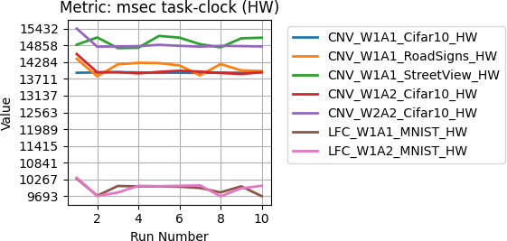

Figure 5: Task Clock (msec) for HW Runtimes of the Models
Figure 5 depicts the task-clock (in milliseconds) for different configurations of BNN model running on hardware. The task-clock remains relatively consistent across multiple runs, indicating stable performance. It is evident that the convolutional models exhibit higher task-clock values as compared to LFC models.
From figure 6 and 7, it can be concluded that cache references and misses are more fre- quent in convolutional classifiers. It depicts an undesired level of memory access in such resource-constrained devices.
For model configurations based on LFC layers, context-switches are efficiently handled. With a high value of CPU Utilization obtained for the same, the convolutional models seem to have bottlenecks in thread synchronization.
Program Counter (PC) writes occur when the PC value is updated by the processor. The number signifies how frequently instructions are fetched, branches and jumps are exe- cuted, and function calls and context-switches have occurred. The relatively high value of PC writes in convolutional models resemble the cache misses, branch mispredictions, and corresponding pipeline flushes.

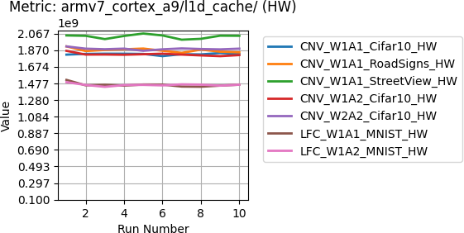

Figure 6: L1 Data Cache References for HW Runtimes of the Models
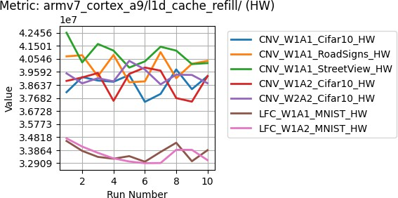

Figure 7: L1 Data Cache Refills for HW Runtimes of the Models

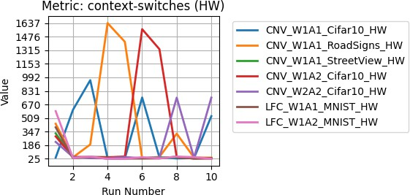

Figure 8: Context Switches for HW Runtimes of the Models

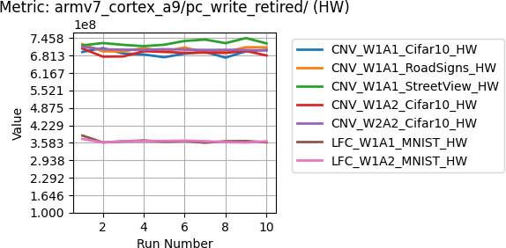

Figure 9: PC Writes for HW Runtimes of the Models

Comparison between Models initialized with Software (SW) Run- time
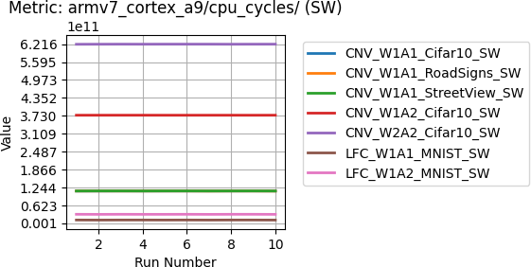

Figure 10: CPU Cycles for SW Runtimes of the Models

From figure 10, it is concluded that all models exhibit relatively consistent performance across multiple runs. A high value of CPU cycles has two aspects viz. speed of instruction execution, and presence of unnecessary cycles. Inefficient handling of custom (e.g.: bit- wise) operations used in software implementations of BNN by standard software libraries can cause such unnecessary cycles.
CPU migrations involve moving processes from one CPU core to another. The convolu- tional classifier model initialized with 1 weight bit and 2 activation bits has high and unsta- ble count of cpu-migrations. It raises a need to study redistribution pattern of processes to improve resource balancing in the above-mentioned configuration.

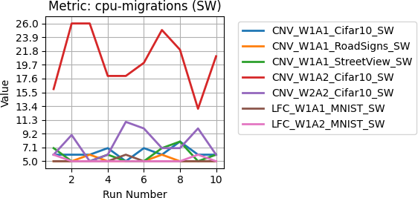

Figure 11: CPU Migrations for SW Runtimes of the Models

Comparison between Models trained on different Datasets
One of such instance is presented below where the classifier model has convolutional layers with 1 bit weight and 1 bit activation, trained on three different datasets. The rate of store instructions (data writes from registers to memory) retired varies depending on the dataset used.
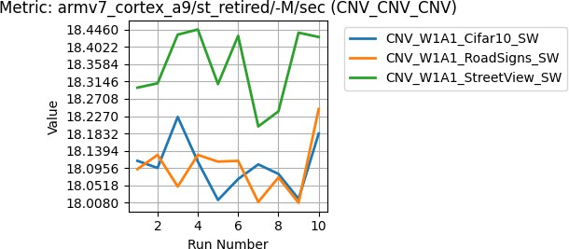

Figure 12: Rate of store instructions retired

Such an observed difference resembles the dissimilar data distribution and data depen- dencies. Except the discussed metric, other metrics observed do not show much difference when the model is initialized with the same set of number of weight bits and activation bits.

Role of number of bits
The difference in performance metrics is studied for the same classifier initialized with dif- ferent combinations of number of weight and activation bits.
With more bits used in quantization, the context-switch time has increased. It can be claimed that cache invalidation and pipeline stalls are faced in the model initialized with more number of activation bits.

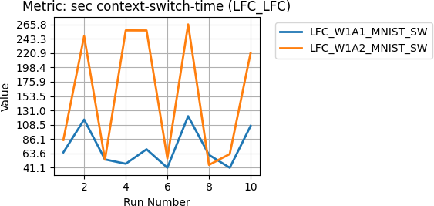

Figure 13: Context Switch Time in seconds

Comparison between hardware and software runtime.
During initialization, the runtime parameter of the model whether or not to use bitstream file. If the runtime is selected as RUNTIME HW, appropriate bitstream overlay is loaded to the FPGA. For RUNTIME SW, no such bitstream file is loaded. It provides a motivation towards comparing the performance metrics of the two configurations. The count of page
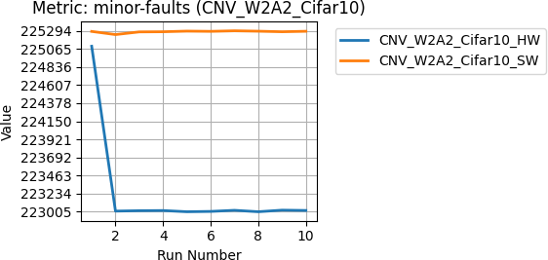

Figure 14: Relative minor faults in hardware and software runtime
faults of the model initialized with hardware runtime is appreciably less than that of the model initialized with software runtime. The hardware runtime might involve additional setup steps specific to hardware acceleration, that may include FPGA bitstream loading, configuring hardware resources, and/or caching mechanisms. After it, a steep decline of page-faults is observed which levels out to remain constant for subsequent runs. Without hardware acceleration, number of page faults is much higher.

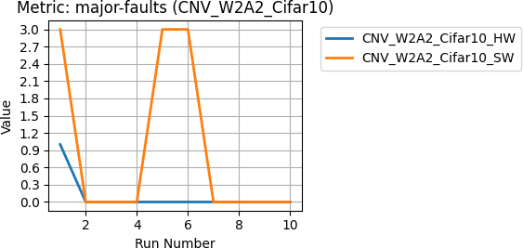

Figure 15: Relative major faults in hardware and software runtime

Observations

Limitations of the Device for the Experimentation
To extend the scope of TinyML models considered in the experimentation, several other implementations were planned. A pretrained model was prepared using MobileNet [24] network and Cifar10 [19] dataset. The model of format Hierarchical Data Format 5 (h5) was then converted to tflite format. Installation of TensorFlow Lite is essential to make in- ference on the PYNQ-Z1 hardware platform [25]. However, a matching version was found for neither of TensorFlow and TensorFlow Lite for PYNQ-Z1. Manual installation provides two options, namely build with bazel [26] or with CMake [27]. Due to version incompatibil- ity, neither of the two methods worked. Similarly, Symmetric Quantization (SYQ) ResNet model was pretrained and tested on remote platform (colab) [28]. However, the same could not be deployed on the PYNQ-Z1 platform.
The implementation of these can be achieved with further research on the PYNQ-Z1 board after loading the latest released version of its boot image [16]. Although Open Neural Network Exchange (ONNX) [29] appears as one of the alternatives for TensorFlow Lite, it could not be installed on the PYNQ-Z1 board because of multiple version incompatibilities. Another choice PYNQ-Torch [30] needs to be explored.

An overview of the Network Architecture
To set a strong base for further research, it was also necessary to know the network archi- tecture of the deployed models. One of such is included as Table VII. The architecture pre- sented here is for a model of deep learning that is optimised for hardware deployment, most likely for FPGA implementations. It starts with data preparation with Mem2Stream Batch and then uses StreamingDataWidthConverter to transform input data into a streaming for- mat that can be used for convolutional operations. These convolutional layers (L0 to L5) gather features from the input in stages, followed by StreamingMaxPool Precision Batch operations that downsample feature maps. The model then moves on to fully connected layers (StreamingFCLayer Batch), including a particular WidthAdjustedOutputStream for output preparation, before concluding with Stream2Mem Batch, which converts processed

data back to memory format. Each layer is rigorously built with parameters optimised for efficient data processing and resource utilisation on hardware platforms, with a focus on streaming data management and optimised data width conversions, both of which are crit- ical for real-time performance and hardware efficiency.

Potential Bottlenecks

Convolutional Models
      - High Task-Clock Values: As per the observation, convolutional models exhibit higher task-clock values as compared to LFC models. It indicates the computational complex- ity of convolution operations as a potential cause.
      - Frequent Memory Access: Figure 6 and 7 illustrate that frequent cache references and misses are encountered by convolutional classifiers.
      - Thread Synchronization: High context-switch time and CPU utilization value point to possible bottleneck in thread synchronization. Efficient management of threads is required to avoid performance degradation.
    - General Performance Issues
      - Pipeline Flush: A high number of Program Counter writes correlate with cache misses, branch mispredications, and pipeline flushes. There are potential bottlenecks in in- struction fetch and execution.
      - CPU Cycles in Software Runtime: According to the depictions of figure 10, all models exhibit high CPU cycles in software runtime. It is caused due to inefficient handling of bitwise computations and/or other custom operations by standard software libraries.
      - CPU Migrations: The high and unstable counts of CPU migrations suggest a need for improved process redistribution.

Table 7: CNV W1A1 HW Architecture Description
Layer No. | Layer Name | Size | Stream
0 | ConvLayer | (30, 30, 32) | inter1
1 | ConvLayer | (28, 28, 64) | inter2
- | StreamingMaxPool | (14, 14, 64) | inter3
2 | ConvLayer | (12, 12, 128) | inter4
3 | ConvLayer | (10, 10, 128) | inter5
- | StreamingMaxPool | (5, 5, 128) | inter6
4 | ConvLayer | (3, 3, 256) | inter7
5 | ConvLayer | (1, 1, 256) | inter8
6 | StreamingFCLayer | (1024) | inter9
7 | StreamingFCLayer | (512) | inter10
8 | StreamingFCLayer | (10) | wa out
- | Stream2Mem | - | Memory

  - Areas of Improvement
Subject to identification of specific layers and/or operations causing the above bottlenecks, the following are identified as possible modifications that will enhance the performance.
    - Optimization of Convolutional Operations
The complexity of the convolutional layers can be reduced, possibly through techniques of depthwise separable convolutions or optimized libraries.
    - Memory Management
More efficient cache management strategies, possibly specific to the cache hierarchy of the PYNQ-Z1 board, will definitely help in reducing cache misses.
    - Improvement in Thread Synchronization
Since the execution of convolutional operations are predicted to be multi-threaded, fine- tuning of thread management is proposed to be one of the desired enhancements.
    - Reduction of Pipeline Flushes
Instruction fetch and execution need an improvization in order to minimize the branch mis- predictions.
    - Bitstreams for other TinyML models
To make models of other format compatible as well as hardware accelerated, custom bit- streams need to be developed for other TinyML models, namely MobileNet, MicroNet, RNN, AutoEncoder [31].

- Conclusion
This study investigates the performance metrics of Binary Neural Networks (BNNs) in- stalled on the PYNQ-Z1 platform, using both hardware and software runtimes for assessing efficiency. By incorporating perf as a performance analysis tool, key metrics such as task- clock, L1 data cache references and refills, context-switches, CPU cycles, and page faults were systematically examined.
The findings demonstrate that the two convolutional models (CNV W1A1 and CNV W1A2) have higher task-clock values and more frequent cache accesses and misses, in- dicating that these models are computationally complex and require intense memory ac- cess. These factors lead to potential thread synchronisation problems, as evidenced by long context switches and high CPU utilisation. Furthermore, high Programme Counter (PC) writes correlate with pipeline flushes, indicating inefficiencies in the instruction fetch and execution operations.
Models initialised with software runtimes, on the other hand, displayed partially steady performance but required a significant number of CPU cycles due to conventional software libraries’ inadequate handling of customised operations. This problem is exacerbated by frequent and unreliable CPU migrations, emphasising the need for better process dispersal and resource allocation.
The comparison of hardware and software runtimes indicated an obvious distinction in page fault counts, with hardware-accelerated models having much fewer page faults. This emphasises the importance of hardware acceleration in lowering memory manage- ment overhead and improving overall performance.
Several areas for improvement have been found to optimise BNN performance on the PYNQ-Z1 platform. These include simplifying convolutional processes, improving cache management tactics, fine-tuning thread synchronisation, lowering pipeline flushes, and cre- ating specialised bitstreams for various TinyML models like MobileNet and MicroNet.

References
- P. P. Ray, ”A review on TinyML: State-of-the-art and prospects,” Journal of King Saud University - Computer and Information Sciences, vol. 33, no. 6, pp. 715-728, July 2021.
- Kallimani, R., Pai, K., Raghuwanshi, P., Iyer, S., & Lo´pez, O. L. A. (2023). TinyML: Tools, Applications, Challenges, and Future Research Directions. Department of Elec- trical and Electronics Engineering, KLE Technological University, Belagavi, Karnataka, India; Faculty of Information Technology and Electrical Engineering, University of Oulu, Finland.
- Song Han, Huizi Mao, and William J. Dally. Deep Compression: Compressing Deep Neural Networks with Pruning, Trained Quantization and Huffman Coding. In Pro- ceedings of the 4th International Conference on Learning Representations, ICLR 2016, San Juan, Puerto Rico, May 2-4, 2016, Conference Track Proceedings, 2016.
- Digilent Inc. PYNQ-Z1 Reference Manual. Digilent, 2017. Available at: https://reference.digilentinc.com/ media/reference/programmable-logic/pynq- z1/pynq-z1 rm.pdf.
- Sadri, M., Weis, C., Wehn, N., & Benini, L. (2015). Energy and performance explo- ration of accelerator coherency port using Xilinx ZYNQ. In Proceedings of the 2015 Design, Automation & Test in Europe Conference & Exhibition (DATE). In Proceedings of the 2015 Design, Automation & Test in Europe Conference & Exhibition (DATE), 2015.
- Gupta, S., et al. (2020). A Survey of Tiny Machine Learning: Opportunities and Chal- lenges. ACM Computing Surveys.
- Courbariaux, M., et al. (2016). Binarized Neural Networks: Training Neural Net- works with Weights and Activations Constrained to +1 or -1. arXiv preprint arXiv:1602.02830.
- Zhang, Y., et al. (2021). Performance Evaluation of ARM Cortex-A Cores for Tiny Ma- chine Learning. IEEE Transactions on Emerging Topics in Computing.
- Li, X., & Wang, S. (2022). Case Study: Tiny Machine Learning on PYNQ-Z1 Board. Proceedings of the International Conference on Embedded Systems.
- Chen, H., et al. (2023). Energy Efficiency Analysis of TinyML on ARM-based Plat- forms. ACM Transactions on Embedded Computing Systems.
- W. Sung, S. Shin, and K. Hwang. Resiliency of deep neural networks under quantiza- tion. CoRR, abs/1511.06488, 2015.
- Y. Bengio, N. Leonard, and A. Courville, ”Estimating or Propagating Gradi- ents Through Stochastic Neurons for Conditional Computation,” arXiv preprint arXiv:1308.3432, 2013.
- Xilinx. (n.d.). PYNQ-Z1 Setup. Retrieved from https://pynq.readthedocs.io/en/v2.3/ getting started/pynq z1 setup.html
- Xilinx. (n.d.). BNN-PYNQ. Retrieved from https://github.com/Xilinx/BNN-PYNQ
- PYNQ Documentation. (n.d.). PYNQ microSD Card. Retrieved from https://pynq.readthedocs.io/en/latest/pynq microSD card.html

- Xilinx. (n.d.). PYNQ Releases.
Retrieved from https://github.com/Xilinx/PYNQ/releases
- Win32 Disk Imager. Available at: https://win32diskimager.org/
- S. Tatham, PuTTY: A Free SSH and Telnet Client, 2024. [Online]. Available at: https://www.putty.org/
- A. Krizhevsky, ”Learning Multiple Layers of Features from Tiny Images,” Technical Report, University of Toronto, 2009.
- Y. Netzer, T. Wang, A. Coates, A. Bissacco, B. Wu, and A. Y. Ng, ”Reading Digits in Natural Images with Unsupervised Feature Learning,” in NIPS Workshop on Deep Learning and Unsupervised Feature Learning, 2011.
- J. Stallkamp, M. Schlipsing, J. Salmen, and C. Igel, ”The German Traffic Sign Recogni- tion Benchmark: A multi-class classification competition,” in Proceedings of the IEEE International Joint Conference on Neural Networks (IJCNN), 2011, pp. 1453-1460.
- Y. LeCun, L. Bottou, Y. Bengio, and P. Haffner, ”Gradient-based learning applied to document recognition,” Proceedings of the IEEE, vol. 86, no. 11, pp. 2278-2324, 1998.
- Perf: Linux profiling with performance counters. Available at: https://perf.wiki.kernel.org/index.php/Main Page
- A. G. Howard, M. Zhu, B. Chen, D. Kalenichenko, W. Wang, T. Weyand, M. Andreetto, and H. Adam. Mobilenets: Efficient convolutional neural networks for mobile vision applications. arXiv preprint arXiv:1704.04861, 2017
- TensorFlow. TensorFlow Lite inference. [Online]. Available: https://www.tensorflow. org/lite/guide/inference
- Bazel. Bazel Build System. [Online]. Available: https://bazel.build/
- CMake. CMake Build System. [Online]. Available: https://cmake.org/
- Julian Faraone, Nicholas Fraser, Michaela Blott, Philip H.W. Leong. SYQ: Learning Sym- metric Quantization For Efficient Deep Neural Networks. In Proceedings of the 2018 IEEE Conference on Computer Vision and Pattern Recognition (CVPR).
- ONNX. Open Neural Network Exchange. [Online]. Available: https://github.com/ onnx/onnx
- Manohar Vohra, Stefano Fasciani. PYNQ-Torch: A Framework to Develop PyTorch Acceler- ators on the PYNQ Platform. In Proceedings of the 2019 IEEE International Symposium on Signal Processing and Information Technology (ISSPIT 2019), 2019. Available at: https://github.com/manoharvhr/PYNQ-Torch/
- Banbury, C., Reddi, V. J., Torelli, P., Holleman, J., Jeffries, N., Kiraly, C., Montino, P., Kanter, D., Ahmed, S., Pau, D., Thakker, U., Torrini, A., Warden, P., Cordaro, J., Di Guglielmo, G., Duarte, J., Gibellini, S., Parekh, V., Tran, H., Tran, N., Wenxu, N., Xuesong, X. (2019). MLPerf Tiny Benchmark In proceedings of the IEEE International Symposium on Signal Processing and Information Technology (ISSPIT 2019). Avail- able at: https://arxiv.org/abs/2106.07597.

